MACH4METAL

metalworking machinery
Transito 21
6909 DA BABBERICH Netherlands
Tel. +31 (0)316-247123
Fax: +31 (0)316-247956
info@mach4metal.com
www.mach4metal.com

Bank No : 66.52.13.883
IBAN : NL33 INGB 0665 2138 83
BIC : INGBNL2A

HARDINGE BRIDGEPORT VMC 1000

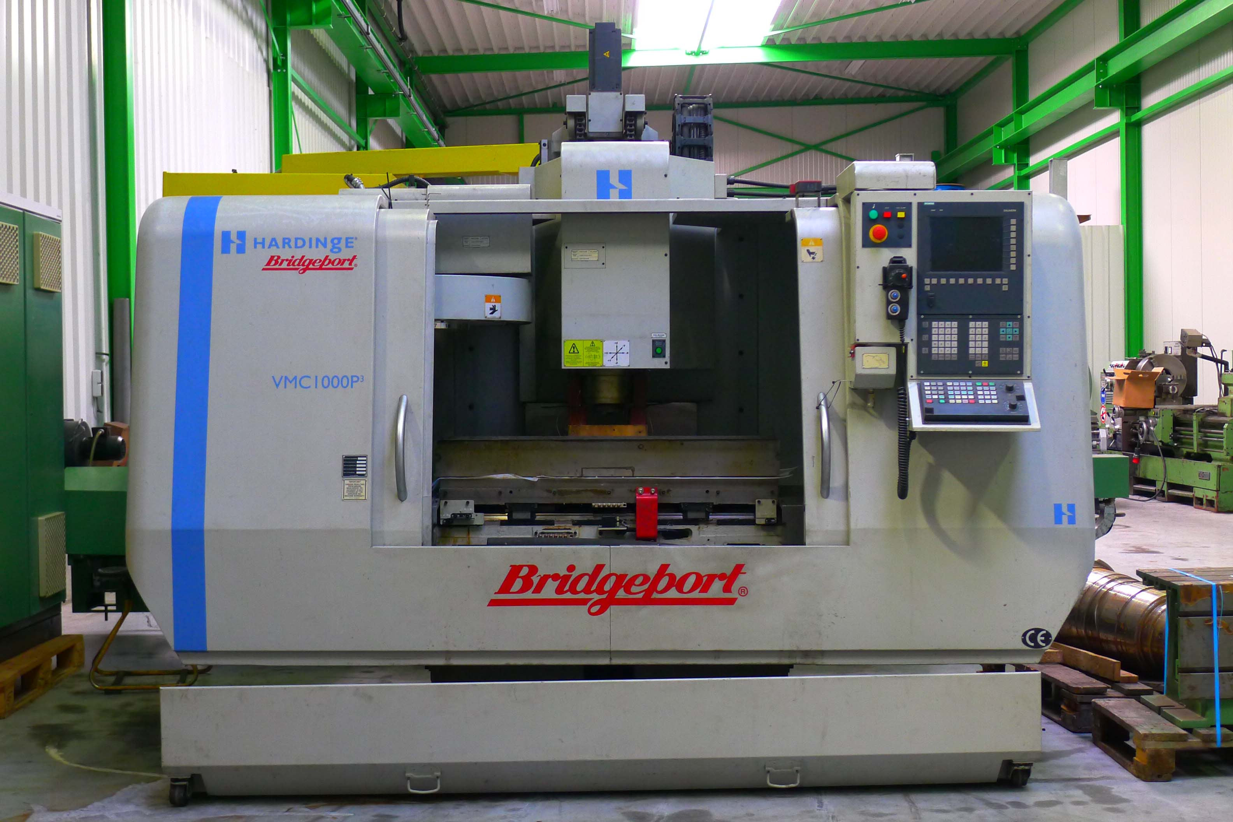
- Make : Hardinge Bridgeport
- Typ : VMC 1000 P³
- No. :
- Age : 2005 – 4500 Hours ?

- Capacity – Travel
- X - Travel : 1.020
- Y - Travel : 510
- Z - Travel : 510

- Table dimensions:
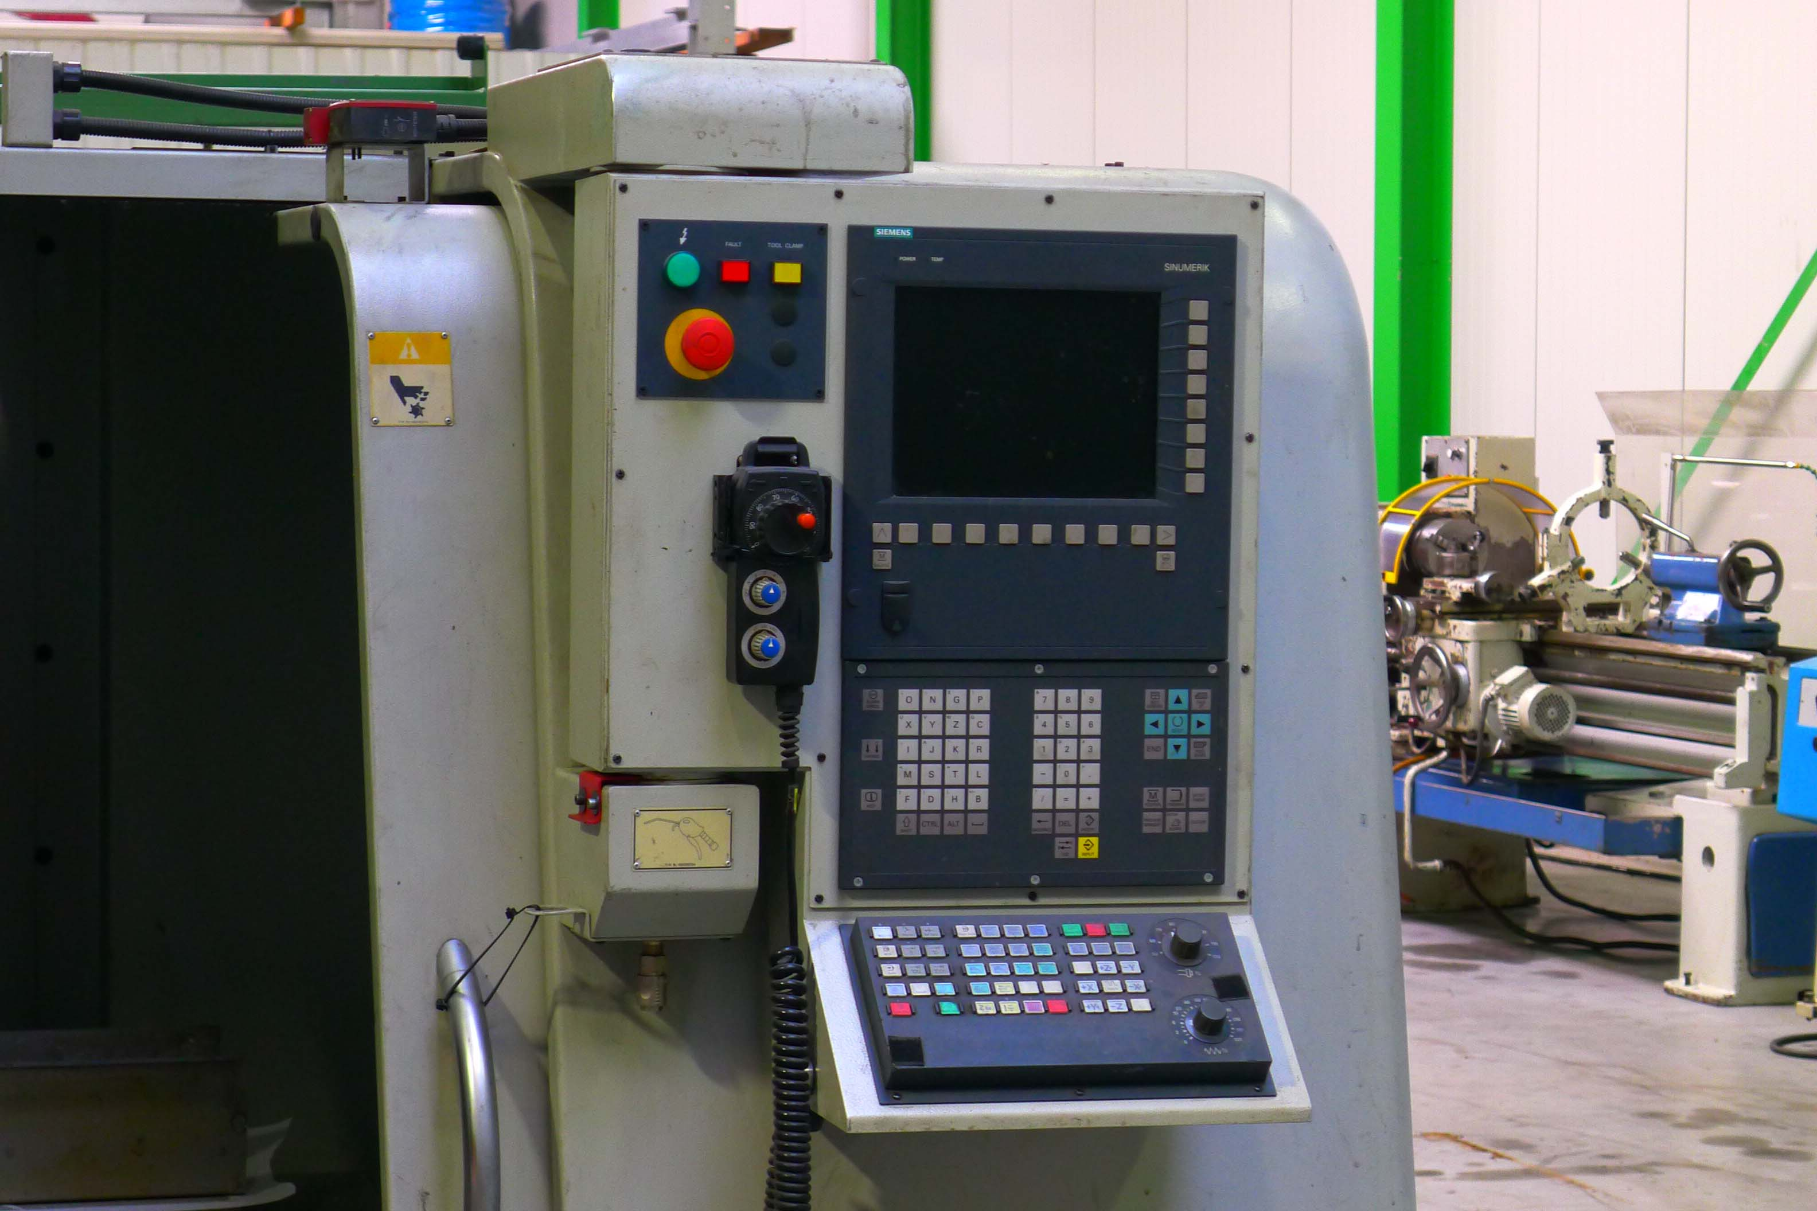
- Length : 1.120
- Width : 510
- Load : 700 Kg

- Rapid traverse : 30.000 mm
- Feed rate : 12.000 mm

- Spindle : BT 40
- Speeds : 8.000 Rpm
- Spindle power : 13 kW
- Spil – Table : 155 - 655
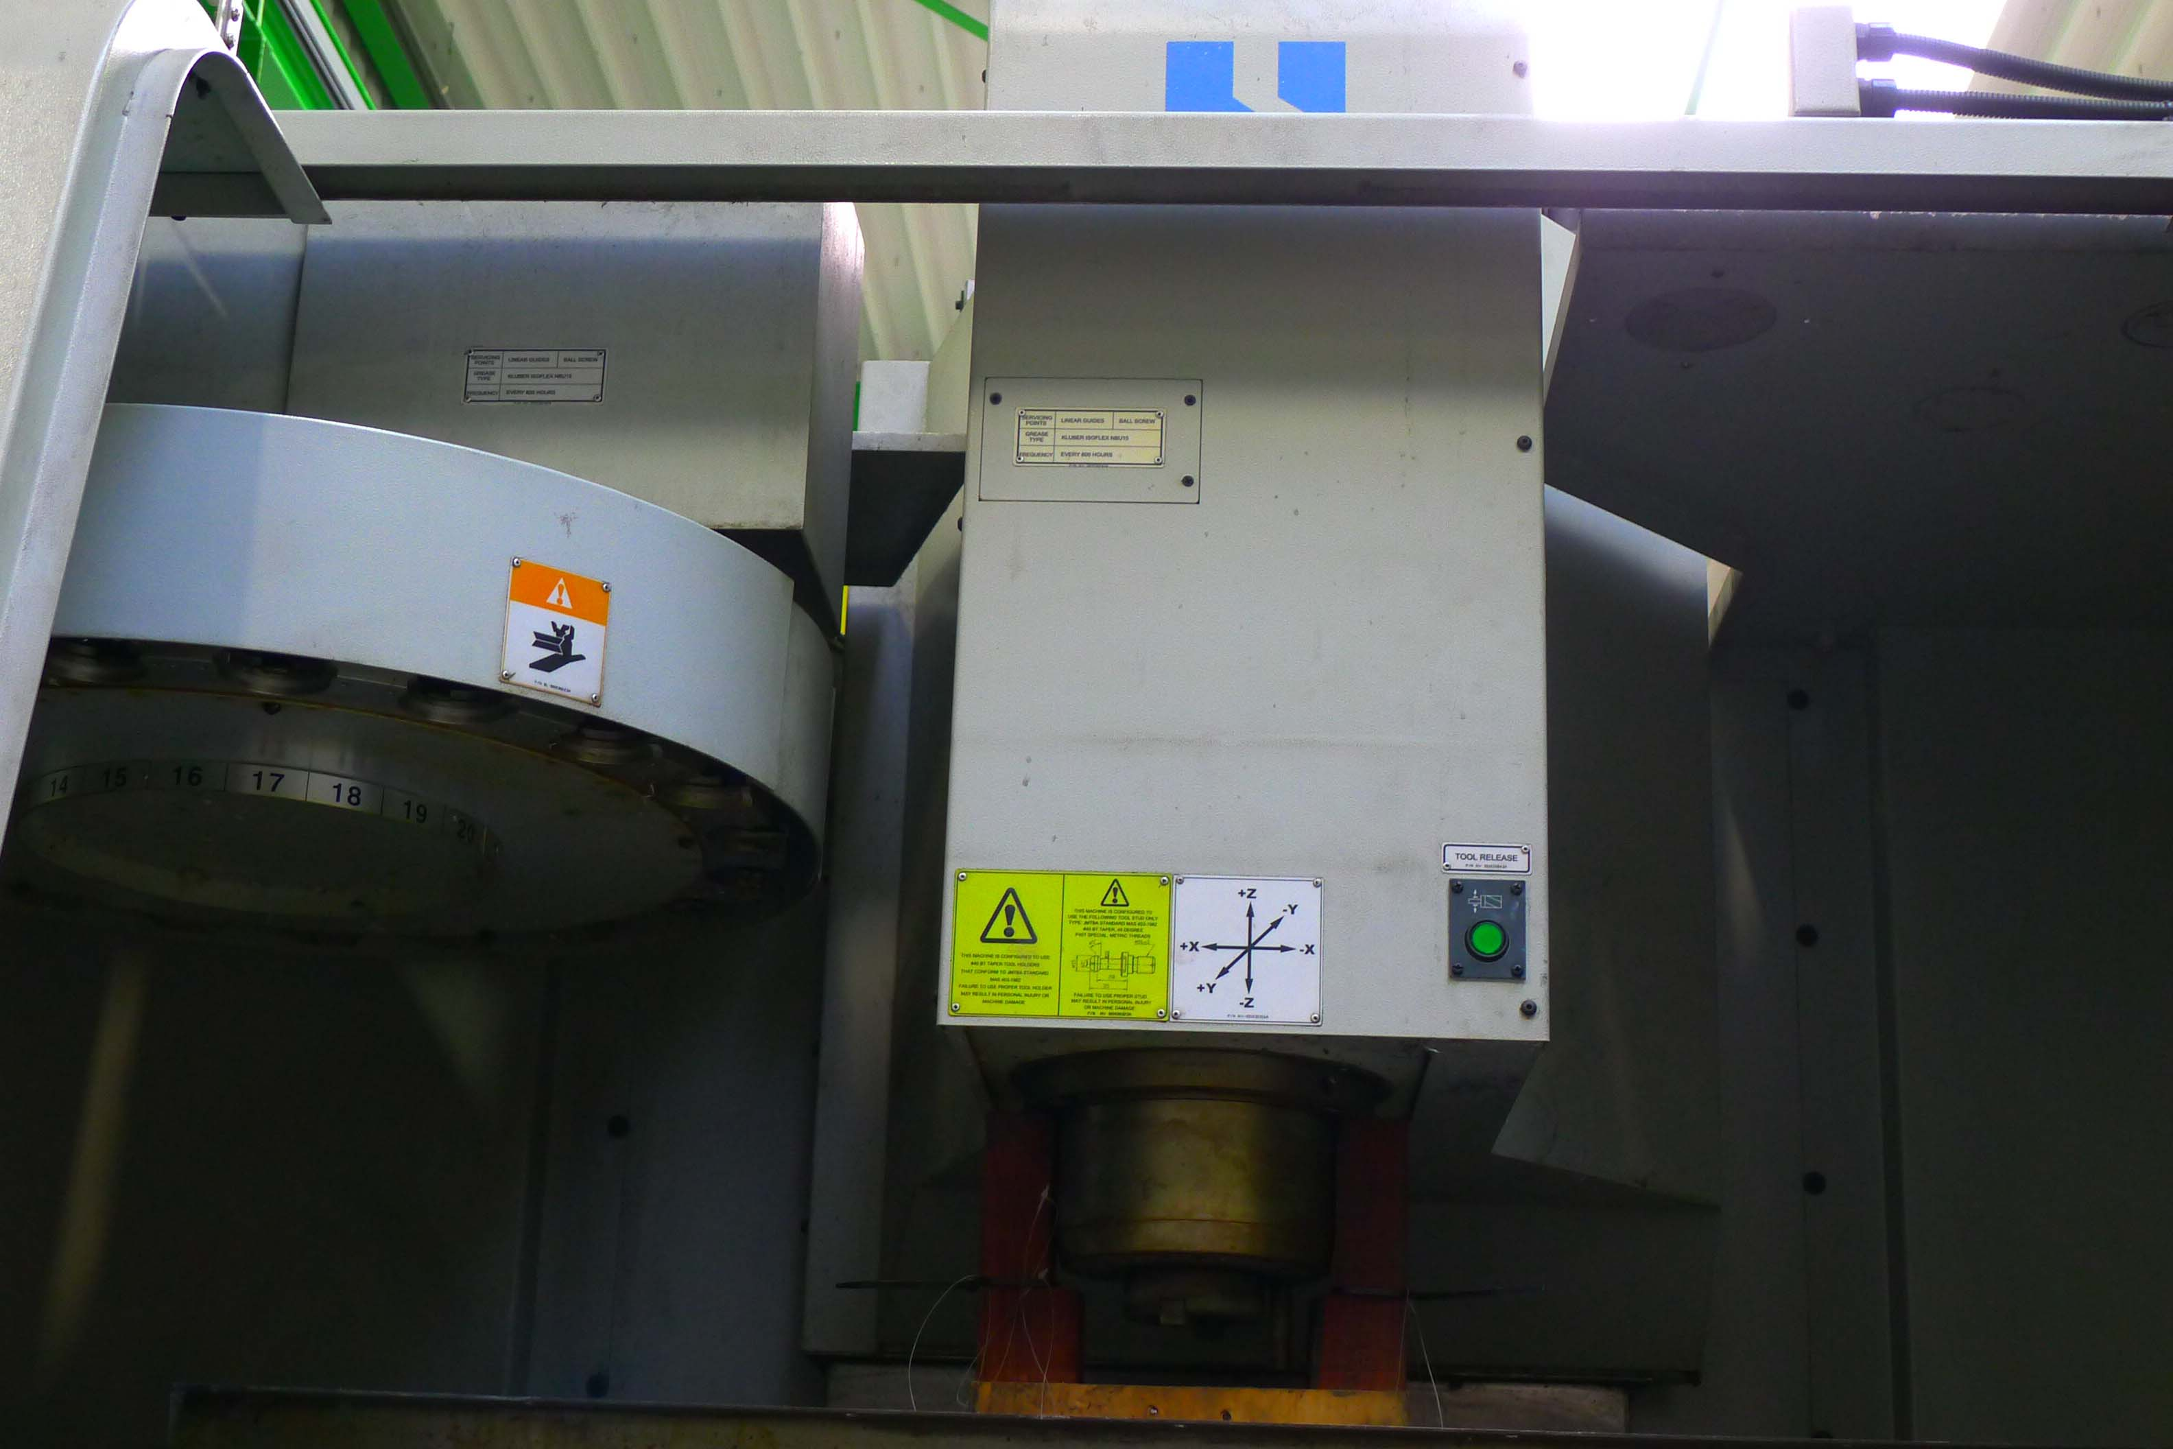

- Dimensions:
- Length : 2.960
- Width : 2.168
- Height : 2.576
- Weight : 4.620 Kg

- CNC SIEMENS 810 Shop mill
- ATC with 20 tools

Please Note: The above information has been obtained to the best of our ability and belief from, and from the manufacturers where possible. It is given in good faith, but its accuracy can not be guaranteed. Accordingly, it will not form a representation or constitute contractual terms. We advise you to check any vital details!

